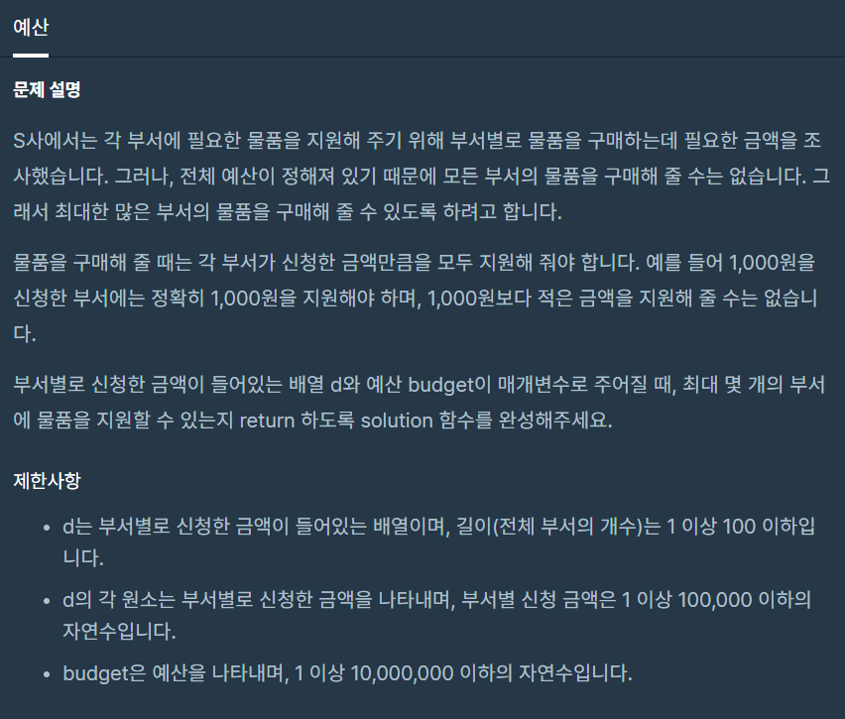

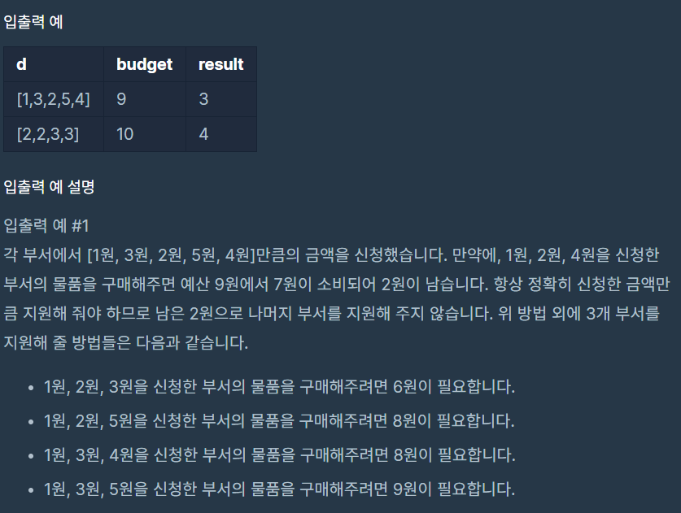



**문제 링크주소 :** <https://programmers.co.kr/learn/courses/30/lessons/12982>

**풀이**

function solution(*d*, *budget*) {

    var answer = 0;

    var sum = 0;

    var i = 0;

*d*.sort(function(*a*,*b*){return *a*-*b*});

    while(sum <= *budget*){

        sum+=*d*[i]

        i++;

    }

    answer = *d*.length-(*d*.length-i)-1;

    return answer;

}